Activity: Python 2 ACT/Bonus

File: Py1_PA_Task2_team59.py

Date: September 23, 2015

By: Kathryn Atherton

katherto

Ryan Hellyer

rhellyer

Natalie Zimmermann

zimmermn

Section: 4

Team: 59

ELECTRONIC SIGNATURE

Kathryn Atherton

Ryan Hellyer

Natalie Zimmermann

The electronic signatures above indicate that the program submitted for evaluation is the combined effort of all team members and that each member of the team was an equal participant in its creation. In addition, each member of the team has a general understanding of all aspects of the program development and execution.

Task 1—Part A

|  |  |  |
| --- | --- | --- |
| Logic Operations | Hand Calculation | Python Calculation |
| A and B | False | 0 |
| A or B | True | 1 |
| A == B | False | False |
| (A and B) == (A or B) | False | False |
| A != B | True | True |
| A < B | False | False |
| A <= B | False | False |
| A = B | No output | TypeError |

Task 1—Part B

1. The answers to logic expressions 1 and 2 are different from what we computed because we did not anticipate that using 0 and 1 as false and true would output 0 and 1 as false and true as well. The answer to logic expression 8 was different from what we computed because, while we realized that there would be an output error, we did not anticipate what that error would be exactly.

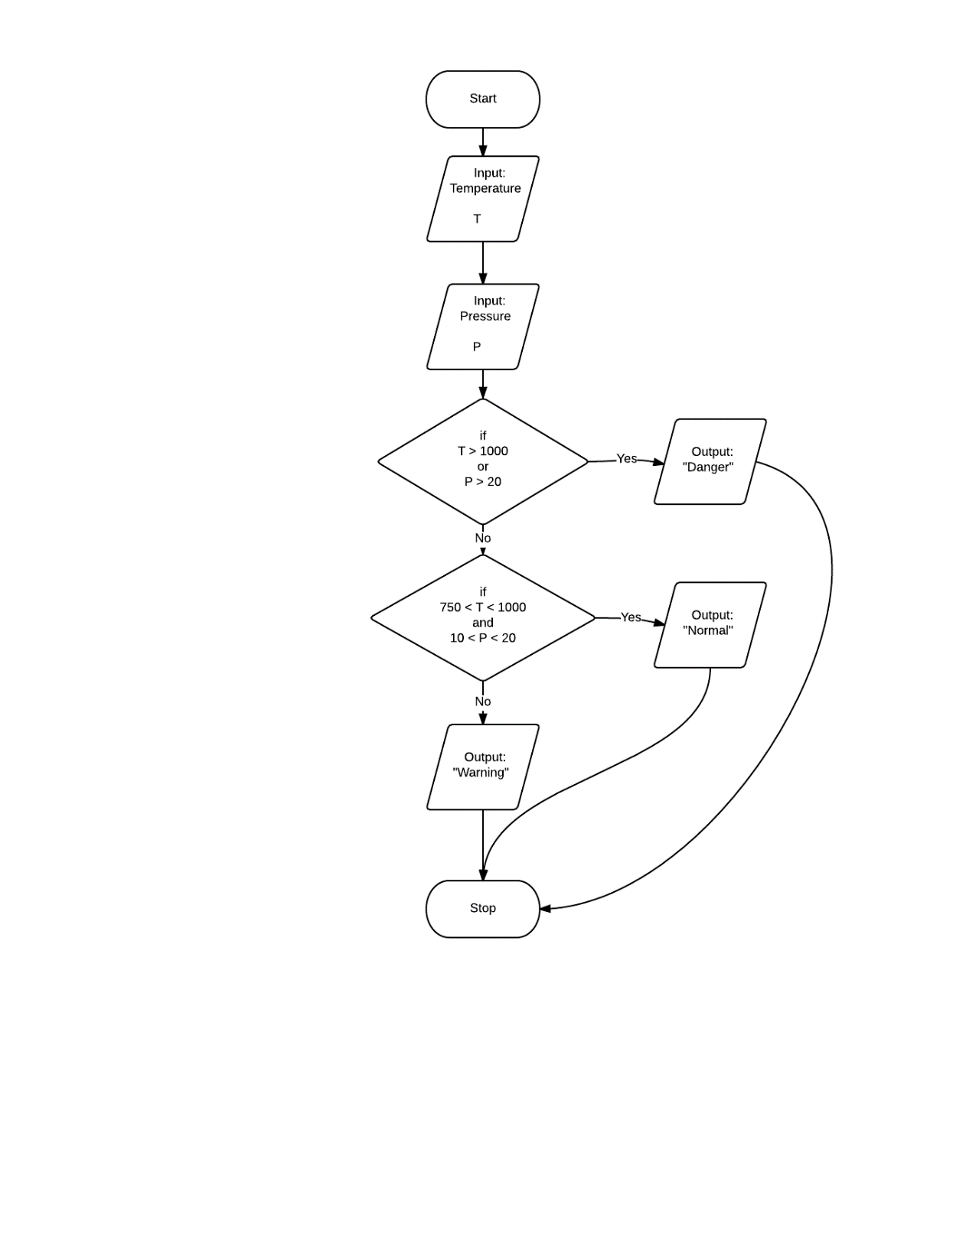Task 1—Part C

1. The output for the following test cases will be:
   1. Normal
   2. Danger
   3. Warning
2. It is important to be able to utilize logical, conditional, or comparison operations in programs in order to define different actions based on all the possible situations that may arise.

Task 1—Part D

The results for the program were as follows:

1. Normal
2. Danger
3. Warning

Task 2—Part A

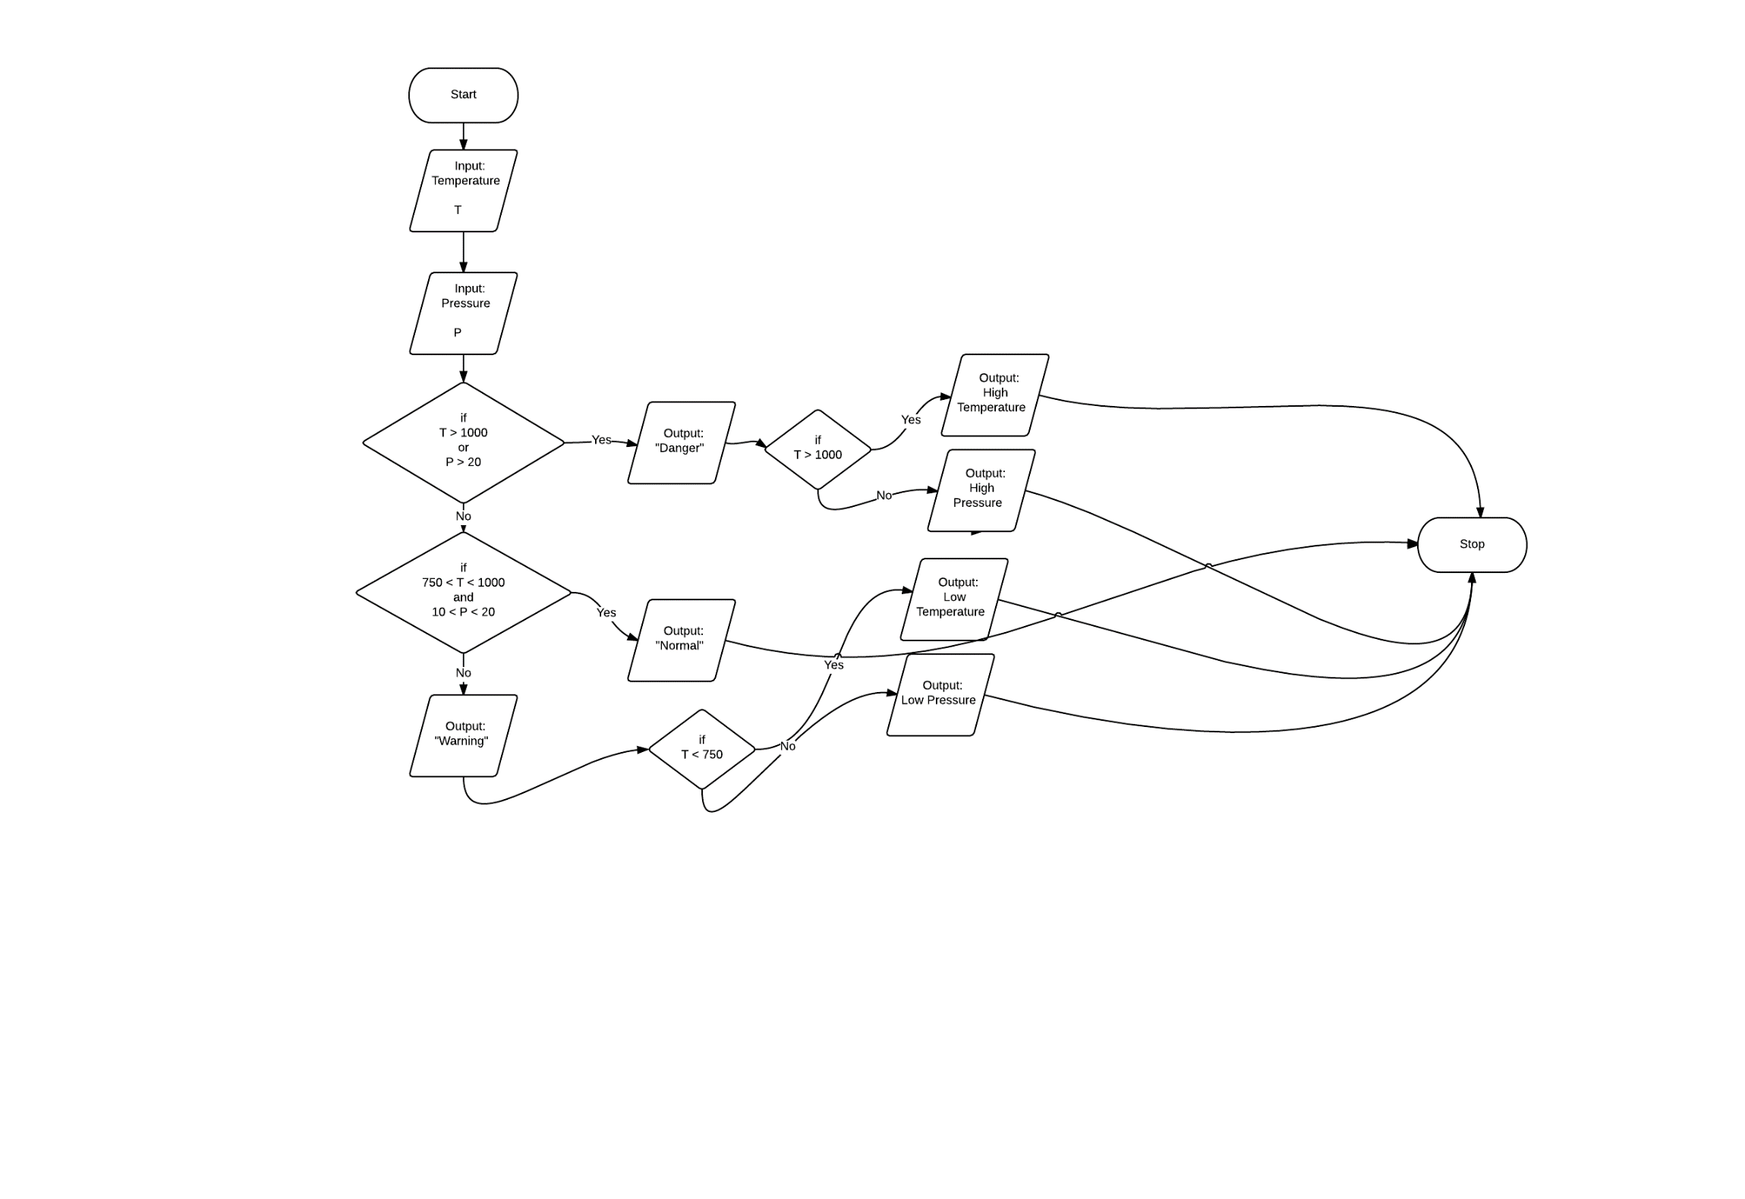

1. The output for the following test cases will be
   1. Normal
   2. Danger
      1. High Pressure
   3. Warning
      1. Low Temperature

Task 2—Part B:

1. The output for the test cases were
   1. Normal
   2. Danger
      1. High Pressure
   3. Warning
      1. Low Temperature

TASK 3

1.-What Python function can you use to output variables to the screen?

To output variables on screen we can use the function print

2.- What syntax differences exist between the two Python functions (distanceRover and solarPanelArea)?

First of all the name is different, also the variables used in each function differ. And last, the “body” of the function distanceRover computes the distance the rover drives, while solarPanelArea computes de area of the solar panel

3. What syntax differences exist in your Python program when calling these two functions?

The identifier differs, you call each function with a different name

4. What are the differences between a main program and a called function in Python? What are the advantages of user-defined functions in Python?

The main differences are that a function is predefined and you can call it anytime during the program, while each main program line just executes once.

The advantages are the modularization, the user can “call” the function anytime. It also reduces redundant code and helps to keep the program “clean”

TASK 4

Part A:

1.- What happens when you run Py2_ACT_Task4_Main_login.py?

A nameError is produced, because the variable ‘R’ is not defined

2.- What happens when you change line 5 of the Python file from print(R)to print(radius)?

In that case the program prints 2 numbers: 5 and 25

3.- What happens when you change line 4 of the Python file from print(A) to print(area)?

A nameError is produced, because ‘area’ is not defined

4. What happens when you add a line in your function such as global area just after the definition line and then change line 4 of the Python file from print(A) to print(area)?

No error is produced, the program works normally

5. What does it tell you about the difference between local and global variables?

It shows that local variables are not very useful in a larger program, because you cannot employ the variable everywhere, while a global can be “called” from anywhere

Part B:

1.- Are S1 and S2 global or local variables?

S1 and S2 are local variables, because they are only defined in the file Areas.py

2.- What is the advantage or disadvantage of the method of calling variables used in the function rectArea compared with the method used in the function circArea?

One advantage is that this way, we directly have the values we want to compute, and don’t have to worry about wether the variables are in the scope or not.

The disadvantage on the other hand, is that this method is not as flexible, we would have to change the variables manually everytime. If, for example, we wanted to take user inputs as the variables, the first method would be more convenient.